API & REST API ??????????????

Let’s dive deeper into both concepts, with **detailed examples** and comparisons to make the differences between **API** and **REST API** clearer.

1. **API (Application Programming Interface)
API (Application Programming Interface)
API (Application Programming Interface) is a set of rules that allows two applications to communicate with each other.
For example, a client application (frontend, mobile app, or another service) sends a request to the server, and the server processes the request and sends back a response.
In modern backend development, we commonly use REST APIs over HTTP to enable this communication.
*What It Is?
An API is a broad term that refers to any set of rules and protocols that allow one software application to interact with another. APIs enable different systems, software components, or services to communicate and share data or functionality.
- **General Concept**: An API is a way for two software components to talk to each other. It defines methods and data structures that developers can use to interact with a system without needing to understand its internal workings.
- Types: APIs can be web-based, libraries, or operating-system-based. They can also be implemented using different protocols (like HTTP, SOAP, or even binary protocols like gRPC).
Examples: APIs can be implemented in various forms, such as web APIs, library APIs, or operating system APIs. For example, a Java API provides predefined methods and classes that can be used in Java applications.

How It Works:
- When you use an API, you're making calls or requests to another system, which then sends data or functionality back.
- APIs aren't restricted to web interactions. They can be used to interact with databases, operating systems, device firmware, or libraries.
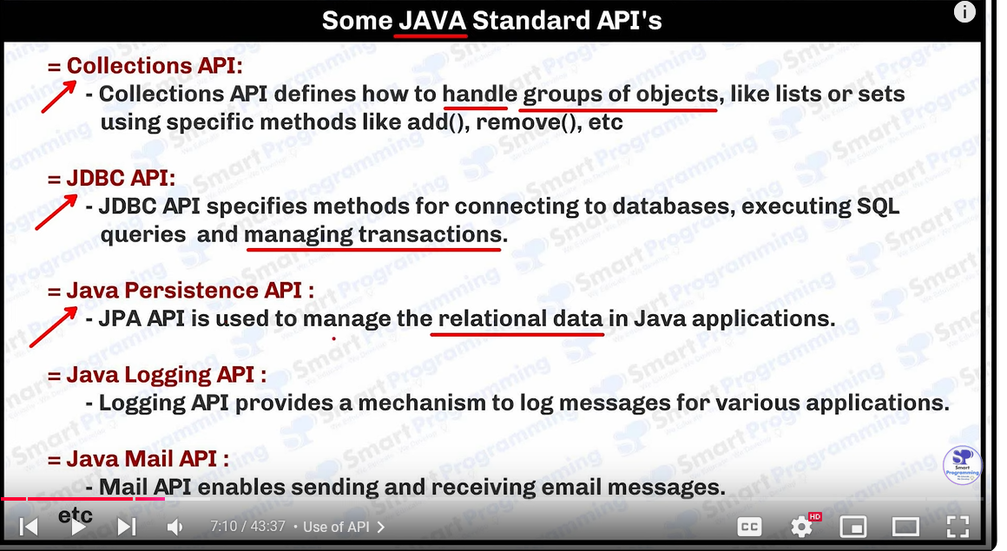
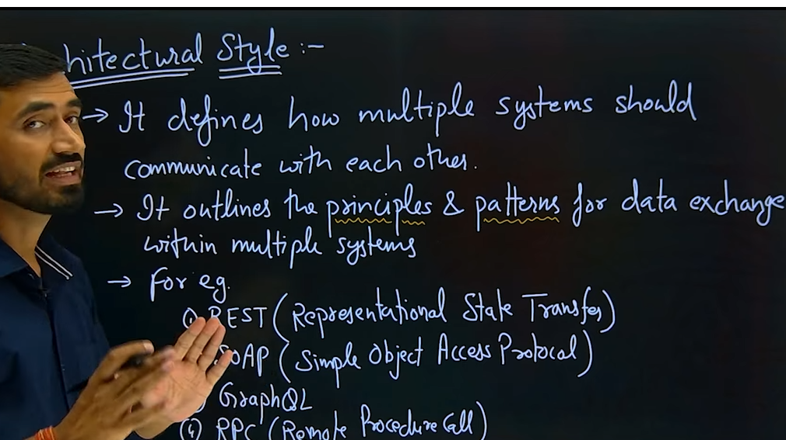
#### **Example of a General API**:
Think of Java’s `List` API. You use its predefined methods (like `add()`, `remove()`, `size()`) to manipulate lists without knowing how these methods work internally.

```java
List<String> names = new ArrayList<>();
names.add("John");
names.add("Jane");
System.out.println(names.size()); // Using the API of the List class
```

In this case, the API exposes functionality to manipulate lists without you needing to understand the internal data structure or algorithm.

*Web APIs:
APIs used over the internet to interact between servers and applications, often by sending HTTP requests. Examples include:
- **SOAP API**: A protocol-based API that uses XML to communicate between systems.
- **GraphQL API**: A flexible query language API for fetching specific data.
- **gRPC API**: A high-performance, binary protocol API that works over HTTP/2.

---
2. REST API (Representational State Transfer API)
What It Is: ?
- A REST API is a specific type of web API that follows the principles of REST architecture. REST (Representational State Transfer) is an architectural style that uses HTTP for communication and defines a set of constraints for creating stateless, scalable, and uniform APIs.

- Specific Type of API**: A REST API is a web-based API that conforms to the constraints of REST (an architectural style for web services).
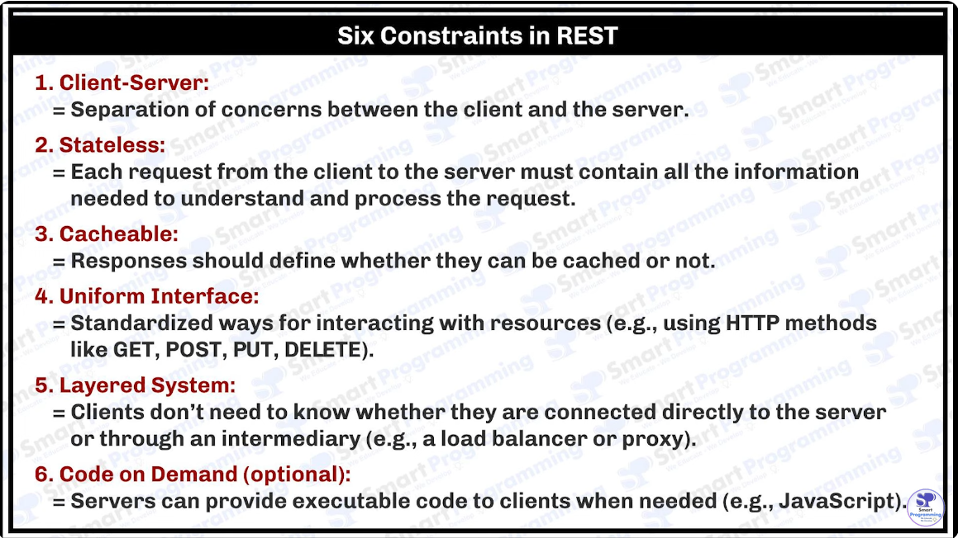
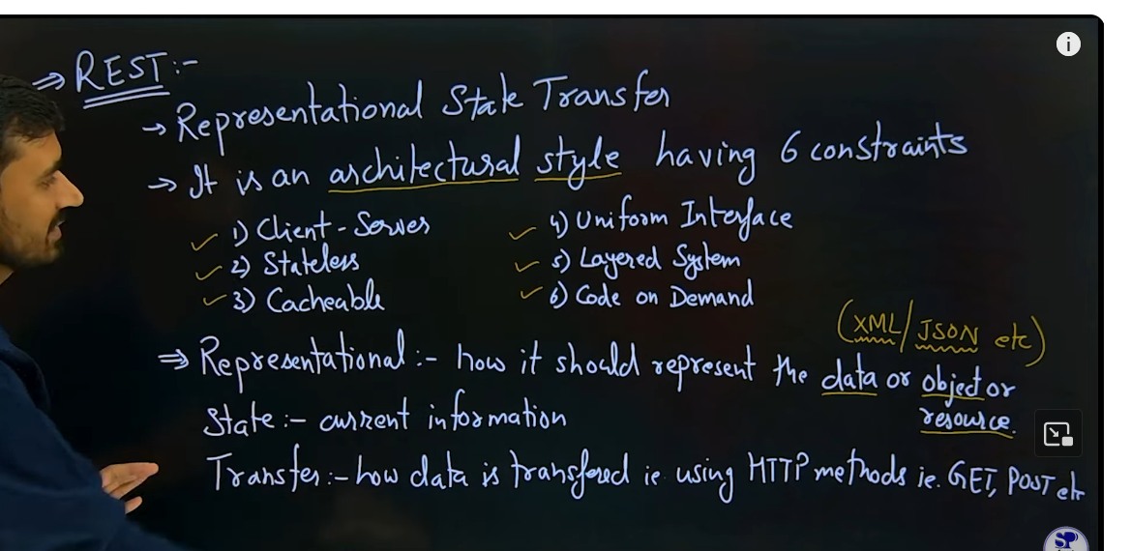
Why Stateless in REST?

- Statelessness**: REST APIs are stateless, meaning each request from a client to a server must contain all the information necessary to understand and process the request, with no reliance on previous interactions (no server-side session). This ensures:

    - Scalability: Servers don’t store client state, so they can handle more requests efficiently.
    - Simplicity: Each request is independent, which simplifies server design and makes REST easy to implement.
    - Reliability: Failure in one request doesn't affect subsequent requests.

  - **HTTP-Based**: REST APIs use standard HTTP methods like:
  - `GET`: Fetch resources.
  - `POST`: Create new resources.
  - `PUT`: Update existing resources.
  - `DELETE`: Remove resources

- Resource-Oriented**: REST APIs treat everything as a resource, and resources are represented as URIs (Uniform Resource Identifiers), e.g., `/api/users/1`.
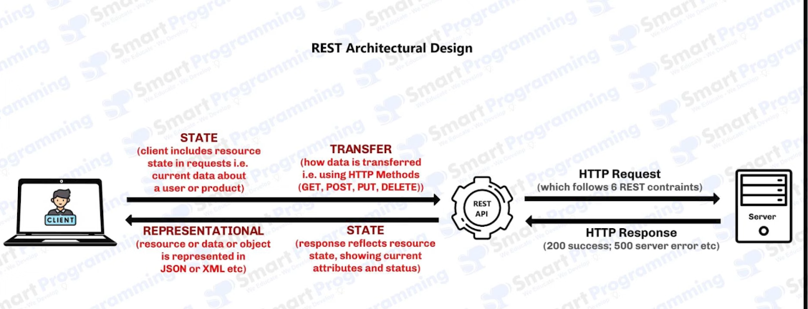
#### **REST API Example**:
Let’s say you’re building an online book store and need a REST API to manage books. Here's how you might structure REST API calls:

- **GET** `/books`: Retrieve a list of books.
- **GET** `/books/123`: Retrieve a specific book by ID.
- **POST** `/books`: Add a new book to the store.
- **PUT** `/books/123`: Update the information of a book with ID 123.
- **DELETE** `/books/123`: Remove the book with ID 123.

**Sample code using RestTemplate in Spring Boot to consume a REST API**:

```java
RestTemplate restTemplate = new RestTemplate();
String bookUrl = "https://api.example.com/books";
ResponseEntity<List<Book>> response = restTemplate.exchange(
bookUrl, HttpMethod.GET, null, new ParameterizedTypeReference<List<Book>>() {});
List<Book> books = response.getBody(); // Consuming REST API
```

- **Explanation**: This code fetches a list of books from a REST API using a `GET` request, then processes the response to get the list of books.

#### **Data Format**:
- REST APIs commonly use JSON (though XML can be used as well).
- Here’s an example JSON response for a `GET /books/123` request:

```json
{
"id": 123,
"title": "Clean Code",
"author": "Robert C. Martin",
"price": 45.99
}
```
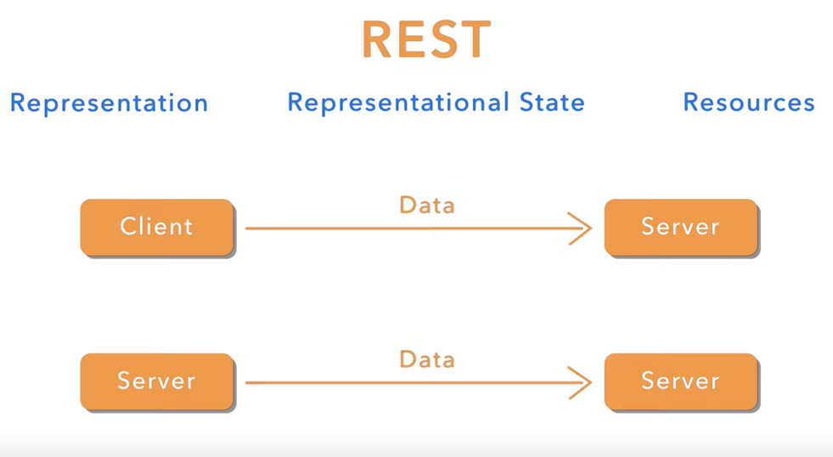

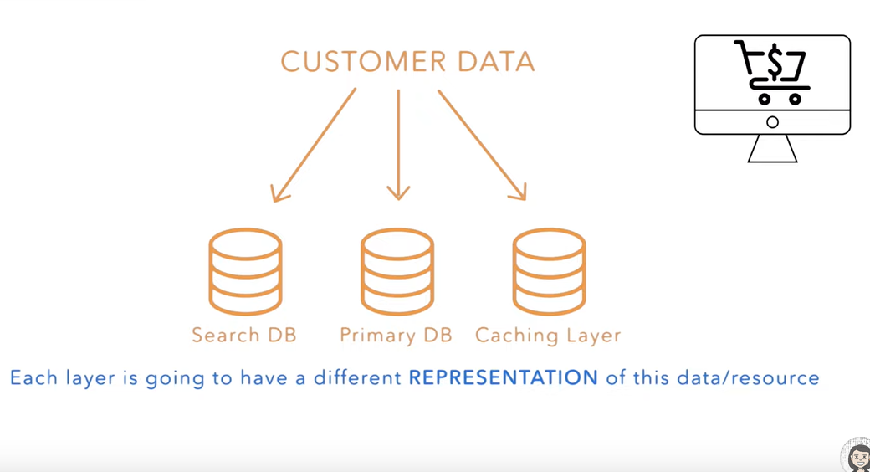
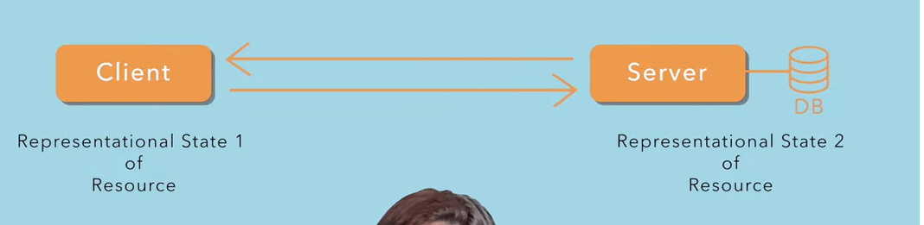

The representation of resources/data we send from client might not be the same as we store we in the database so that means same data have different 2 different representation, also this data transfers from one layer to another.
We represent the data in a particular state we called representation data.

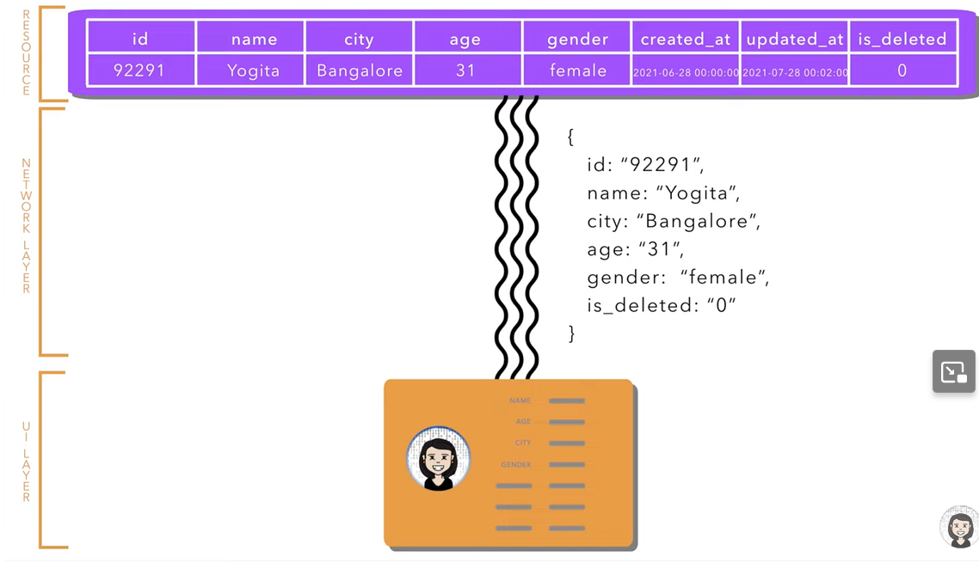

REST API is all about
- managing these resources, creating, updating deleting these resources.
- How to represent these resources in different layer.
- Hoe to pass these resources from one layer to another

REST API is an architectural style that uses http for communication and the resources are represented as URIs
A REST API uses the HTTP protocol to perform operations (like GET, POST, PUT, DELETE) on resources, which are identified and accessed through URIs (Uniform Resource Identifiers).

HTTP vs HTTPS

1. **HTTP (Hypertext Transfer Protocol)
- Security: Not secure. Data is sent in plain text, making it vulnerable to eavesdropping.
- Port: Uses port 80.
- Encryption: No encryption, meaning anyone intercepting the traffic can read the data.
- Use Case: Used for non-sensitive communications like public web pages or general browsing.

2. HTTPS (Hypertext Transfer Protocol Secure)
- Security**: Secure. It encrypts data using **SSL/TLS**, protecting information from interception.
- **Port**: Uses **port 443**.
- **Encryption**: Provides encryption, ensuring data privacy and security between the client and server.
- **Use Case**: Used for sensitive communications, such as online banking, e-commerce, and login forms.

---

### Relationship between REST API, HTTP Protocol, URI, and Resources

A REST API operates over the HTTP protocol, allowing clients to interact with server-side resources, which are identified by URIs (Uniform Resource Identifiers), using standard HTTP methods like GET, POST, PUT, and DELETE.

---

Representational State Transfer (REST) - Key Points

- REST is an architectural style for designing networked applications.
- Resources are the key components in REST and are represented by URIs.
- Statelessness: Each request must contain all necessary information, as the server does not maintain any client state between requests. This promotes scalability and simplicity.
- State Transfer: The client and server communicate by transferring the representation of resources using standard formats like JSON or XML.

Path Parameter
- **Definition**: Path parameters are variables in the URL that are used to identify a specific resource. They are embedded directly in the URL path.
- **Usage**: They are commonly used to specify resources in a REST API.
- **Example**: In the URL `http://api.example.com/users/{userId}`, `{userId}` is a path parameter that would be replaced with an actual user ID, such as `http://api.example.com/users/123`.

Query Parameter
- **Definition**: Query parameters are key-value pairs appended to the URL after a question mark (`?`). They are used to filter, sort, or paginate resources.
- **Usage**: They can be optional and are often used for searching and filtering results.
- **Example**: In the URL `http://api.example.com/users?age=25&sort=asc`, `age` and `sort` are query parameters that filter the users based on age and sort order.

In Spring Boot, @RequestParam and @PathVariable are both used to extract values from the HTTP request, but they serve different purposes and work in different ways.
1. @PathVariable:
- Purpose: Extracts values from the URI path (the part of the URL after the domain, excluding the query parameters).
- Usage: It is used to pass dynamic values that are part of the URI itself.
- Example: /orders/{id} — Here, the id is part of the URI and is passed directly in the path.
- How it works in your code:
  - The value of id in the path /orders/1 will be mapped to the Long id parameter in the method.
java

Payload
- **Definition**: The payload is the data sent in the body of a request. It is typically used in POST, PUT, or PATCH requests to send data to the server.
- **Usage**: The payload contains the information needed to create or update a resource.
- **Example**: In a POST request to create a new user, the payload might look like this:
```json
{
"name": "John Doe",
"email": "john.doe@example.com"
}
```

Response Body
- **Definition**: The response body is the data returned from the server in response to a client request. It contains the result of the request, including the requested resource or an error message.
- **Usage**: It is typically formatted in JSON or XML.
- **Example**: After a successful GET request for a user, the response body might be:
```json
{
"id": 123,
"name": "John Doe",
"email": "john.doe@example.com"
}
```

### Summary
- **Path Parameters**: Identify specific resources in the URL.
- **Query Parameters**: Provide optional filtering or sorting for resource retrieval.
- **Payload**: Contains the data sent to the server in requests like POST or PUT.
- **Response Body**: The data returned from the server, providing the result of the request.

---

### **Real-World Project Scenario to Explain API Calls:**

#### **Case: Building an E-Commerce Microservice with REST APIs**

1. **Context**: You are working on a Spring Boot project for an e-commerce platform. Your system consists of different microservices like Product, Order, Payment, and User Management.

2. **API Calls**:
- **User Management Service**: Exposes REST APIs to manage user-related operations.
- Example: `POST /api/users` to create a new user, `GET /api/users/{id}` to get user details.
- **Product Service**: Exposes APIs to handle product information.
- Example: `GET /api/products` to fetch all products, `GET /api/products/{id}` for specific product details.
- **Order Service**: Needs to call the Product and User services to verify product availability and user details before creating an order.
- **Service-to-Service API Call**: Uses `FeignClient` or `RestTemplate` to call the Product Service API (`GET /api/products/{id}`) from the Order Service to check product availability.

#### **Server-to-Server API Call Example**:
- **Feign Client** to make API calls between services:
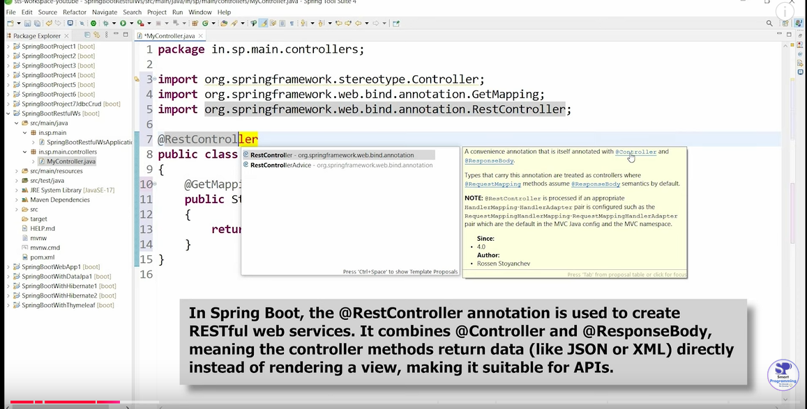
```java
@FeignClient(name = "product-service")
public interface ProductServiceClient {

@GetMapping("/api/products/{id}")
Product getProductById(@PathVariable("id") Long id);
}
```

- **Explanation**: When a user places an order, the Order Service uses `FeignClient` to communicate with the Product Service to check if the product is available. The interaction is stateless, meaning each service call is independent.

---

### **Common Interview Questions to Expect:**

1. **Q: What is the difference between an API and a REST API?**
- **A**: An API is a broad concept for interacting between software systems. A REST API is a specific type of API that follows REST principles, such as being stateless, using standard HTTP methods, and treating data as resources.

2. **Q: Why do you prefer using REST API in your project?**
- **A**: REST APIs are simple, stateless, and scalable, making them suitable for modern web applications, especially microservices architectures. They work well with HTTP and JSON, which are widely supported by modern systems.

3. **Q: How do you handle service-to-service communication in microservices?**
- **A**: I use Feign Client for declarative service-to-service communication, as it simplifies HTTP requests with minimal boilerplate code. Alternatively, RestTemplate is used for synchronous calls, while WebClient is preferred for non-blocking, reactive calls.

4. **Q: What is the advantage of using REST over SOAP?**
- **A**: REST is simpler, more lightweight, and typically uses JSON over HTTP, making it faster and easier to use in modern web applications. SOAP is more complex, heavier due to XML, and has strict protocols, which may not be needed in all scenarios.

---

By combining these detailed explanations with examples from your experience, you'll be able to clearly explain the differences and practical implementations of API and REST API in an interview.

